CS 6327 Video Analytics Assignment 2

Instructor: Dr. B. Prabhakaran TA: Kanchan Bahirat

Due - Feb 19th, 2017

Only submission on eLearning is accepted.

**Description:**

Given an image I with various fruits (Fig. 1), please:

1. Add Gaussian noise with sigma 0.5 to I to create a noisy image N1. Write your own code to remove the noise from the image N1. Let's say the image obtained after noise removal is H1. Tune different parameters of noise removal scheme to obtain the visually good output.
2. Add salt and pepper noise with the noise density 0.02 to I to create a noisy image N2. Write your own code to remove the noise from the image N2. Let's say the image obtained after noise removal is H2. Tune different parameters of noise removal scheme to obtain the visually good output.
3. Create a brightness adjusted image B1 from the image I by adding a constant factor 50.
4. For all images (I, N1, N2, H1, H2, B1), count the number of apples in the images (both red and green apples). Use erosion, dilation, and connected components concepts. You can also modify the erosion/dilation parameters to see how the count varies – especially with respect to the number of apples in the border.

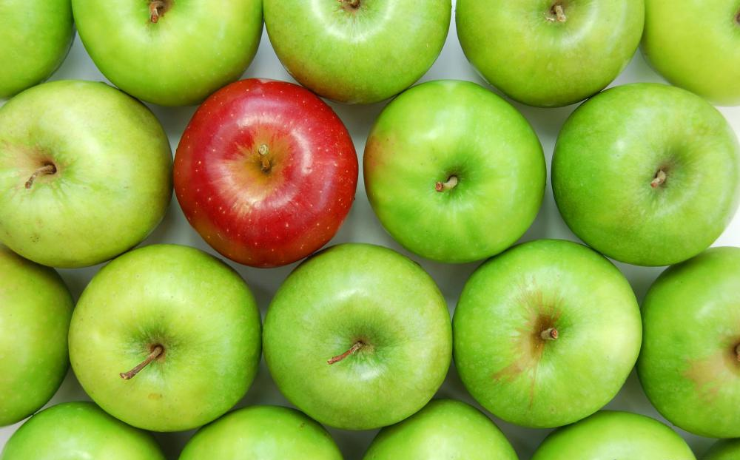

Figure 1: Images with various fruits.

**Desired Output:**

Display **all** the intermediate results. For example,

*Salt and pepper noise added (N2) Denoised Image (H2)*

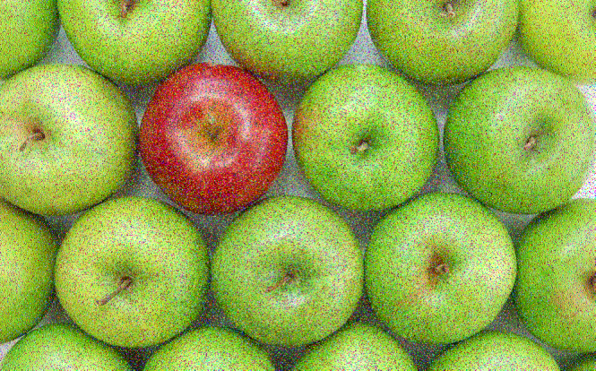 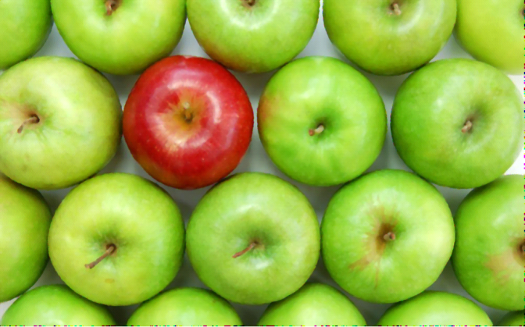

*Birghtness adjusted image:*

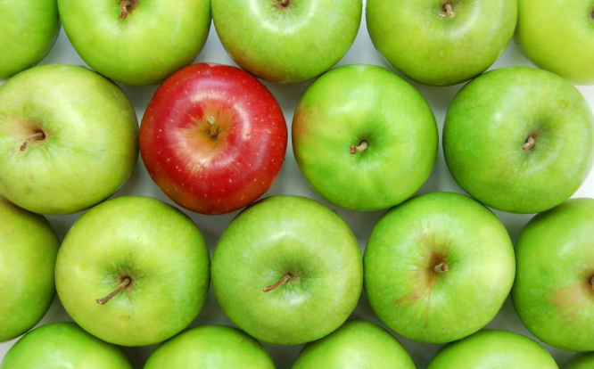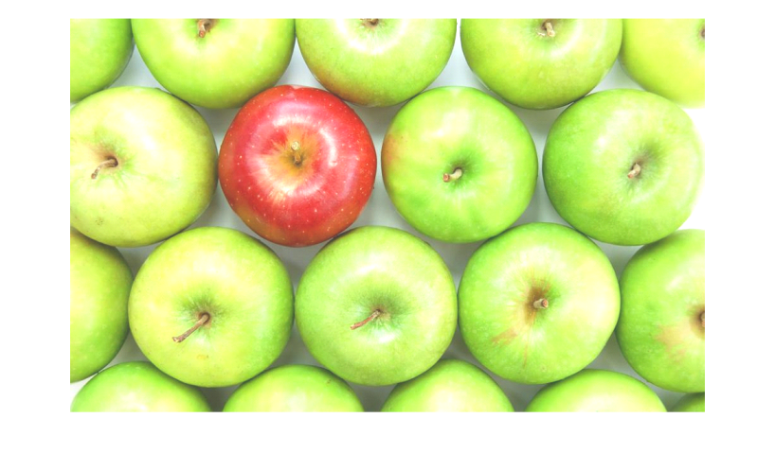

*These are few examples of expected output. You need to show* ***all*** *the intermediate results.*

**Where to submit the assignment:** eLearning.

**Late Submissions: Accepted**. However, there will be a penalty when you are late.

**Rubrics:**

Load and Display Images -- 5 points.

Adding and removing Gaussian noise -- 25 points

Adding and removing salt and pepper noise -- 25 points

Create brightness-adjusted image -- 10 points

Counting apples in all the images -- 35 points

NOTE: Do not use built-in OpenCV functions for step 1 to 3 – operate on each pixel value.